**INFORMATICS & COMPUTATIONAL SCIENCES PROGRAMME**

**UNIVERSITY COLLEGE OF SCIENCE**

**MOHANLAL SUKHADIA UNIVERSITY**

**(NAAC Accredited 'A' Grade University)**

**BACHELOR OF COMPUTER APPLICATION**

**(A Choice Based Credit System)**

**BCA 5th SEMESTER**

**(Batch 2022-23)**



**A Project Report**

**On**

**CAR RENTAL WEBSITE**

**Submitted To : Submitted By:**

**Dr.Avinash Panwar Yogesh Malviya**

**CERTIFICATE**

This is to certify that **YOGESH MALVIYA** has successfully completed the project titled “CAR RENTAL WEBSITE” as a partial fulfilment for the award of the degree in **BACHELOR OF COMPUTER APPLICATION, Mohanlal Sukhadia University (Rajasthan).**

The contents of this report do not form a basis for the award of any previous degree to the above mentioned, or to anyone else, to the best of our knowledge. The software is working perfectly and work is appreciable. We find the quality of the work presented according to our level of satisfaction.

We wish him good luck and success in all her future endeavours.

**DECLARATION**

I hereby declare that the work, which is being presented in this project entitled “**CAR RENTAL WEBSITE**” in partial fulfilment of the requirement for the award of the degree bachelor of computer application, MLSU is an authentic and original record of my own work carried out by me for a period of BCA. 5th Semester (2022-23) .

Also this project has not formed the basis for the award of any other degree, associate ship, fellowship or any other similar titles.

Place: Udaipur

YOGESH MALVIYA

**ACKNOWLEDGEMENT**

The satisfaction that accompanies that the successful completion of any task would be incomplete without the mention of people whom case less cooperation made it possible, whom constant guidance and encouragement crown all efforts with success.

So I am fortunate to find opportunity to express my deep sense of gratitude and sincere thanks to all those people who helped me with their guidance and assistance. Their contribution has been invaluable.

First of all, I am thankful to “MOHANLAL SUKHADIA UNIVERSITY” for keeping this Project in curriculum, which provides real world experience before degree completion.

By being the student of **Mohanlal Sukhadia University, Udaipur**, I convey a sincere thanks to **Dr. Avinash panwar** , for providing all the facilities required for making the project successful..

I would also like to thank all the **faculty members and friends** of **Mohanlal Sukhadia University, Udaipur,** for their hard work, support and inspiration provided by them during the duration of the BCA degree. Their guidance was always fruitful.

**1. INTRODUCTION**

1.1. PURPOSE:

This application is develop to provide best rent car services to the customers and travel agents. We have developed car rent system to provide a search platform where a user can find their best rent car according to their choices. This system also helps to promote responsible and interesting cars so that people can enjoy their holidays at their favorable cars. Car rental is a business that requires a big investment to buy, or lease, and maintain a vehicle fleet. You will have to compete for both with huge and powerful companies like Enterprise, Hertz, Sixt, Europcar, and smaller ones. And in such a tough situation, most of the firms try to sidestep the rivals by proposing better quotes. That is why it is extremely important for small entrepreneurs to keep an eye on every benchmark.

This system also gives cars related information like which car model , attractions, boot capacity, fuel tank and other. User can also book rent car through for journey using of car rental website .

The “Car Rental Website” has been developed to override the problem rent a car and Get a rented car sitting at home manual system. This website supported in almost every browser. This website designed for make car rent need of the provide rented car to user in a smooth and effective manner.

This system also keeps a history of cars of its users.

**1.2. SCOPE:**

The scope of the tour and trawel management includes:

1. Best cars for rent.
2. Powerful car for journey.
3. Best offer cars.
4. Money saving
5. Time Saving

**1.3 Hardware and Software Required**

**Software Requirement:**

Operating System : Windows-XP , Windows-7 ,Windows-8. Toolkit : Notepad++, Xampp.

Front End : PHP

Back End : MySQL

**Hardware specification**

Processor **:** - Intel Core i-3 processor, Core i5 processor.

RAM **:** - 4GB.

SSD : - 512GB.

**TECHNOLOGY USED**

**2.1 Front End Technology:**

2.1.1 HYPERTEXT PRE PROCESSOR (PHP)

The full form of PHP is “PHP Hypertext Pre-processor”. But its original name was “Personal Home Page”. Rasmus Lerdorf software engineer, Apache team member is the creator and original driving force behind PHP. The first part of PHP was developed for his personal use in late 1994. By the middle of 1997, PHP was being used on approximately 50,000 sites across the worldwide.

PHP is a one type of server-side scripting language, which can be embedded in HTML or used as a stand-alone. PHP does not do anything about what a page looks and sounds like. In fact, most of what PHP does is invisible to the end user. Someone looking at PHP page can not necessarily be able to tell that it was not written purely in HTML because usually the result of PHP is HTML.

PHP is fully cross –platform meaning it runs native on several flavours of UNIX, as well as on Windows base system. The PHP allows web developers to create dynamic pages for e-commerce and web applications that are interact with databases. When we embed the PHP code into HTML code at that time if we make a PHP file then we have to give the extension of that file is .**php**. It provides those servers with functionality similar to that provided to windows platform by Active Server Pages technology. It is database supported means we can access commercial and non-commercial databases including Informix, Microsoft SQL server, MySQL, ODBC, Oracle etc.

**2.1.2 HYPERTEXT MARKUP LANGUAGE (HTML)**

A simple markup language used to create hypertext documents that are portable from one platform to another. HTML files are simple ASCII text files with codes embedded (indicated by markup tags) to denote formatting and hypertext links.

Many people who use HTML to create Web pages or other documents find Notepad a useful tool for writing in HTML. Because Notepad supports only very basic formatting, you cannot accidentally save special formatting in documents that need to remain pure text. This is especially useful when creating HTML documents for a Web page because special characters or other formatting may not appear in your published Web page or may even cause errors. Many word processors provide additional tools or converters to help you create HTML documents. But, if you are creating simple pages or if you want to make a few quick changes, Notepad opens files quickly. Also, Notepad shows all of the HTML tags so you can troubleshoot your page. Not all word processors or converters make the HTML code available.

## 2.1.3JQuery

## JQuery is a lightweight, "write less, do more", Java Script library. The purpose of JQuery is to make it much easier to use JavaScript on your website. JQuery takes a lot of common tasks that requires many lines of JavaScript code to accomplish, and wraps it into methods that you can call with a single line of code. JQuery also simplifies a lot of the complicated things from JavaScript, like AJAX calls and DOM manipulation. The jQuery library contains the following features:

* HTML/DOM manipulation
* CSS manipulation
* HTML event methods
* Effects and animations
* AJAX
* Utilities

**2.1.4 JAVASCRIPT**

**JavaScript** is an object-oriented scripting language used to enable programmatic access to objects within both the client application and other applications.

It is primarily used in the form of client-side JavaScript, implemented as an integrated component of the web browser, allowing the development of enhanced user interfaces and dynamic websites. JavaScript is a dialect of the ECMA Script standard and is characterized as a dynamic, weakly typed, prototype-based language with first-class functions.

JavaScript was first developed by Netscape as an open scripting language to create interactive web pages. JavaScript as an open language implies that it can be used by anyone; no license is required to use JavaScript.

JavaScript has the ability to function both as an object oriented language as well as procedural language. Using JavaScript you can create objects, attach methods and properties.

**JavaScript tasks**

* **JavaScript gives HTML designers a programming tool -** HTML authors are normally not programmers, but JavaScript is a scripting language with a very simple syntax! Almost anyone can put small "snippets" of code into their HTML pages
* **JavaScript can read and write HTML elements -** A JavaScript can read and change the content of an HTML element
* **JavaScript can be used to validate data -** A JavaScript can be used to validate form data before it is submitted to a server. This saves the server from extra processing
* **JavaScript can be used to create cookies** - A JavaScript can be used to store and retrieve information on the visitor's computer

**2.1.5 AJAX**

AJAX = Asynchronous JavaScript and XML.

AJAX is a technique for creating fast and dynamic web pages.

Ajax is not itself a technology.

AJAX allows web pages to be updated asynchronously by exchanging small amounts of data with the server behind the scenes. This means that it is possible to update parts of a web page, without reloading the whole page.

Ajax is a way of mixing well-known programming techniques in an uncommon way to develop web applications with appealing user interfaces

Ajax works as an extra layer between the user’s browser and the web server to fill up the lapses of traditional web application development

Examples of applications using AJAX: Google Maps, Gmail, You tube, and Facebook tabs.

**How AJAX Works**

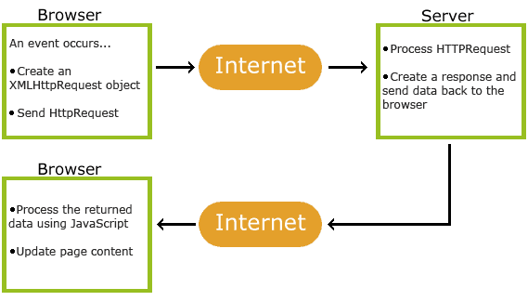

**2.1.6 CASCADING STYLE SHEET (CSS)**

Cascading Style Sheets (CSS) is used to describe the presentation semantics (that is, the look and formatting) of a document written in a mark up language. CSS is designed primarily to enable the separation of document content (written in HTML or a similar mark up language) from document presentation, including elements such as the layout, colours, and fonts. Cascading Style Sheet is used to style HTML elements.

CSS defines the way how to display HTML elements.

**CSS can be added to HTML in the following ways:**

* in separate style sheet files (CSS files)
* in the style element in the HTML head section
* in the style attribute in single HTML elements

**Three Ways to Insert CSS in Web page:-**

* + External style sheet
  + Internal style sheet
  + Inline style

**2.2 Back End Technology:**

MySQL SERVER

A database management system must be able to reliably manage a large amount of data in a multi-user environment so that many users can concurrently access the data. A database management system should also provide security and failure recovery.

MySQL is the name of a database management system Developed by Apache Software Foundation. Apache Software Foundation provides various softwares related to web development; the biggest advantage is that all the software’s are free of cost. MySQL is most popular database management tool. It provides better security and data recovery against system failure.

MySQL works faster compared to other Database Management tools. Apache Software Foundation provides GUI to work with MySQL, because of its GUI environment it is very easy to understand any novice user can quickly learn MySQL by using phpMyAdmin developer. We can create databases and maintain it through phpMyAdmin developer. It provides GUI so it is easy to understand and learn.

MySQL is a database management system, which helps us to manage data stored in a system database. Programming skills is not required to use MySQL as database management system. phpMyAdmin hides all the complex tasks of managing a database and gives a user-friendly way of managing a database.

**2.3 Front & Back End Tool:**

|  |  |  |
| --- | --- | --- |
| **S. no** | **Particulars** | **Technology** |
| 1. | Server side language | PHP |
| 2. | Database | MySQL |
| 3. | Designing | CSS |
| 4. | Validation | JavaScript, JQuery |
| 5. | Structure Designing | HTML |
| 6. | Animation | JQuery |
| 7. | Image Editing | Photoshop |

**SYSTEM ANALYSIS**

**3.1 Project Analysis :**

Project Analysis is a process of gathering and interpreting facts, diagnosing problems and the information to recommend improvements on the project. It is a problem solving activity that requires intensive communication between the project users and project developers. Project Analysis or Study is an important phase of any project development process.

The **Project Analyst** plays the role of the interrogator and dwells deep into the working of the present project. My  **project** is viewed as a whole and the inputs to the project are identified. The outputs from the organizations are traced to the various processes. Project Analysis is concerned with becoming aware of the problem, identifying the relevant and decisional variables, analyzing and synthesizing the various factors and determining an optimal or at least a satisfactory solution or program of action.

**3.2 Feasibility Study:**

Preliminary investigation examine project feasibility, the likelihood the system will be useful to the organization. The main objective of the feasibility study is to test the Technical, Operational and Economical feasibility for adding new modules and debugging old running system. All system is feasible if they are unlimited resources and infinite time. In **car rental website**, there are aspects in the feasibility study portion of the preliminary investigation:

* Technical Feasibility
* Operation Feasibility
* Economical Feasibility

**3.2.1 Technical Feasibility**

In **car rental website**, the technical issue usually raised during the feasibility stage of the investigation includes the following:

* Does the necessary technology exist to do what is suggested?
* Do the proposed equipments have the technical capacity to hold the data required to use the new system?
* Will the proposed system provide adequate response to inquiries, regardless of the number or location of users?
* Can the system be upgraded if developed?
* Are there technical guarantees of accuracy, reliability, ease of access and data security?

**3.2.2 Operational Feasibility:**

Proposed projects are beneficial only if they can be turned out into information system. That will meet the organization’s operating requirements. Operational feasibility aspects of this project **cars** are to be taken as an important part of the project implementation. In **rentcar**, some of the important issues raised are to test the operational feasibility of a project includes the following:

* Will the system be used and work properly if it is being developed and implemented?
* Will there be any resistance from the user that will undermine the possible application benefits?

This system is targeted to be in accordance with the above-mentioned issues. Beforehand, user requirements have been taken into consideration. So there is no question of resistance from the users that can undermine the possible application benefits.

The well-planned design would ensure the optimal utilization of the computer resources and would help in the improvement of performance status.

**3.2.3 Economic Feasibility**

A system can be developed technically and that will be used if installed must still be a good investment for the organization. In **car rental website**, in the economical feasibility, the development cost in creating the system is evaluated against the ultimate benefit derived from the new systems. Financial benefits must equal or exceed the costs.

A system can be developed technically and that will be used if installed must still be a good investment for the organization. In the economical feasibility, the development cost in creating the system is evaluated against the ultimate benefit derived from the new systems. Financial benefits must equal or exceed the costs.

The system is economically feasible. It does not require any addition hardware or software. Since the interface for this system is developed using the existing resources and technologies available at NIC, There is nominal expenditure and economical feasibility for certain.

Economical Feasibility in this project **car rental website** includes the following:

* The cost to conduct a full system check is possible.
* There is no additional manpower requirement.

**3.3 Cost Benefit Analysis:**

Cost Benefit Analysis (CBA), sometimes called Benefit–Cost Analysis (BCA), is a systematic process for calculating and comparing benefits and costs of a project, decision or government policy (hereafter, "project"). CBA has two purposes:

1. To determine if it is a sound investment/decision (justification/feasibility),
2. To provide a basis for comparing projects. It involves comparing the total expected cost of each option against the total expected benefits, to see whether the benefits outweigh the costs, and by how much.

CBA is related to, but distinct from cost-effectiveness analysis. In **car rental website**, benefits and costs are expressed in monetary terms, and are adjusted for the time value of money; so that all flows of benefits and flows of this project **car rental website**, costs over time (which tend to occur at different points in time) are expressed on a common basis in terms of their "net present value."

**4.1 Data Dictionary: Table View**

A database is a collection of data about a specific topic.

**Table Name:Adminuser**

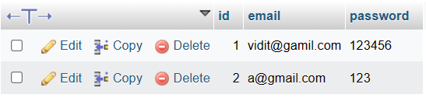

**Table Name:bestofferdata**

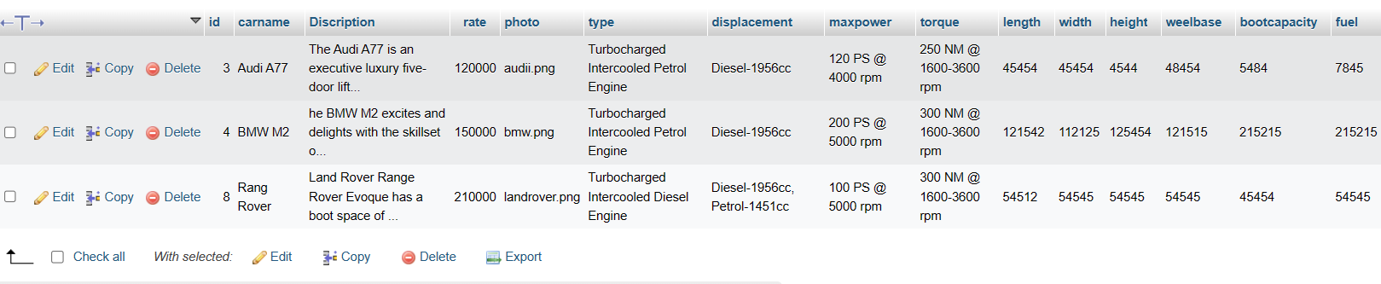

**Table Name: reviewdata**

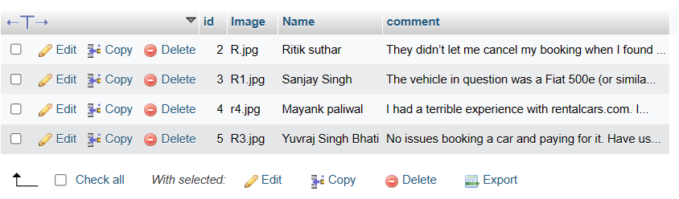

**Table Name:uploadcar**

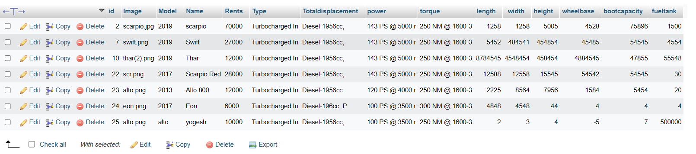

**Table Name: userdata**

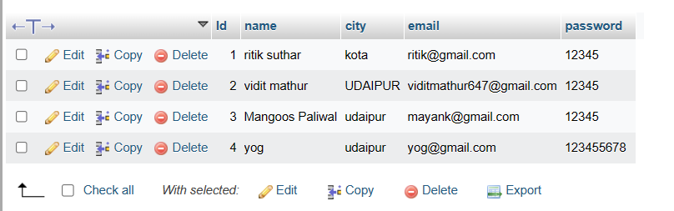

**Table Name:rentcarknow**

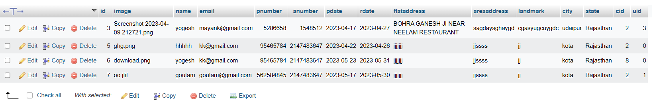

**4.2 Data Flow Diagrams**

A data flow diagram is graphical tool used to describe and analyze movement of data through a system. These are the central tool and the basis from which the other components are developed. The transformation of data from input to output, may be described logically and independently of physical components associated with the system. These are known as the logical data flow diagrams.

The physical data flow diagrams show the actual implements and movement of data between people, departments and workstations. A full description of a system actually consists of a set of data flow diagrams. Using two familiar notations Yourdon, Gane and Sarson notation develops the data flow diagrams. Each component in a DFD is labeled with a descriptive name. Process is further identified with a number that will be used for identification purpose.

The development of DFD’s is done in several levels. Each process in lower level diagrams can be broken down into a more detailed DFD in the next level. The top-level diagram is often called context diagram. It consists of a single process bit, which plays vital role in studying the current system. The process in the context level diagram is exploded into other process at the first level DFD.

The idea behind the explosion of a process into more process is that understanding at one level of detail is exploded into greater detail at the next level. This is done until further explosion is necessary and an adequate amount of detail is described for analyst to understand the process.

Larry Constantine first developed the DFD as a way of expressing system requirements in a graphical from, this lead to the modular design.

A DFD also known as a “bubble Chart” has the purpose of clarifying system requirements and identifying major transformations that will become programs in system design. So it is the starting point of the design to the lowest level of detail. A DFD consists of a series of bubbles joined by data flows in the system.

**Dfd Symbols:**

In the DFD, there are four symbols

1. A square defines a source(originator) or destination of system data.
2. An arrow identifies data flow. It is the pipeline through which the information flows.
3. A circle or a bubble represents a process that transforms incoming data flow into outgoing data flows.
4. An open rectangle is a data store, data at rest or a temporary repository of data.

Process that transforms data flow.

Source or Destination of data

Data flow

Data Store

**Constructing A DFD:**

Several rules of thumb are used in drawing DFD’s:

1. Process should be named and numbered for an easy reference. Each name should be representative of the process.
2. The direction of flow is from top to bottom and from left to right. Data traditionally flow from source to the destination although they may flow back to the source.One way to indicate this is to draw long flow line back to a source. An alternative way is to repeat the source symbol as a destination. Since it is used more than once in the DFD it is marked with a short diagonal.
3. When a process is exploded into lower level details, they are numbered.
4. The names of data stores and destinations are written in capital letters. Process and dataflow names have the first letter of each work capitalized.

**Salient Features OfDfd’s**

1. The DFD shows flow of data but no control loops and decisions are controlled but considerations do not appear on a DFD.
2. The DFD does not indicate the time factor involved in any process whether the dataflows take place daily, weekly, monthly or yearly.
3. The sequence of events is not brought out on the DFD.

**TYPES OF DATA FLOW DIAGRAMS**

1. Current Physical
2. Current Logical
3. New Logical
4. New Physical

* **CURRENT PHYSICAL:**

In Current Physical DFD process label include the name of people or their positions or the names of computer systems that might provide some of the overall system-processing. Label includes an identification of the technology used to process the data. Similarly data flows and data stores are often labels with the names of the actual physical media on which data are stored such as file folders, computer files, business forms or computer tapes.

* **CURRENT LOGICAL:**

The physical aspects at the system are removed as much as possible so that the current system is reduced to its essence to the data and the processors that transform them regardless of actual physical form.

* **NEW LOGICAL**:

This is exactly like a current logical model. If the user is completely happy with the functionality of the current system but had problems with how it was implemented typically through the new logical model, will differ from current logical model while having additional functions, absolute function removal and inefficient flows recognized.

* **NEW PHYSICAL:**

The new physical represents only the physical implementation of the new system.

Dataflow Diagrams:

**Admin Login:**

DataBase

Homepage

Connect to home page

Admin

Enter username

And password

**Admin-Add, Update, View User Details:**

Database

Enter User information

Update user

User Details

Add User

View user information

**Admin-Delete User:**

Database

Delete the User from the Database

User

Details

Admin

**Admin-Add, Update, View Company Details:**

Database

Enter Company information

Update

Company

Company Details

Add Company

View company information

**4.4 SNAPSHOTS**

* 1. **Home Page**

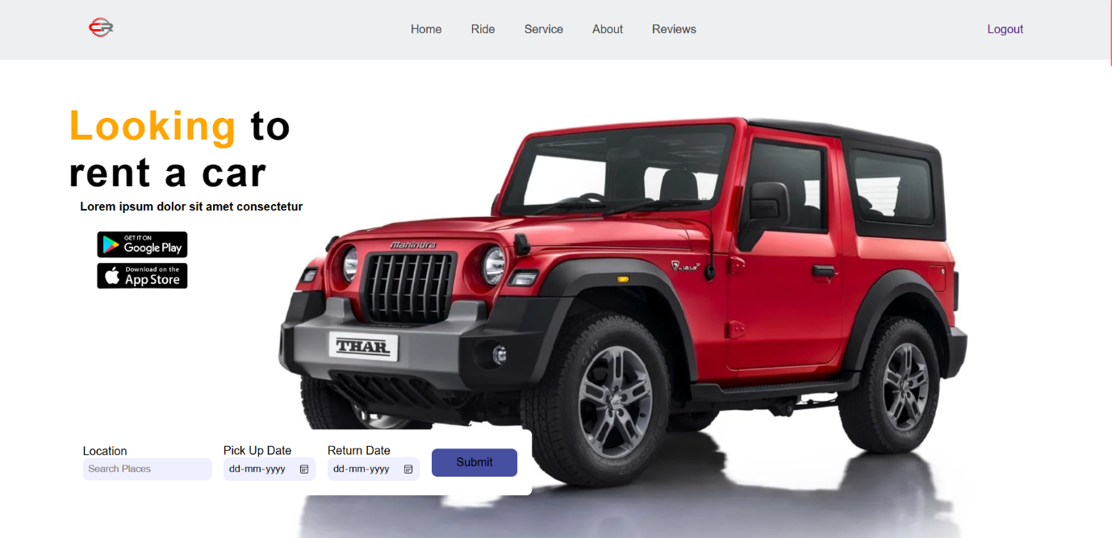

* 1. **Ride**

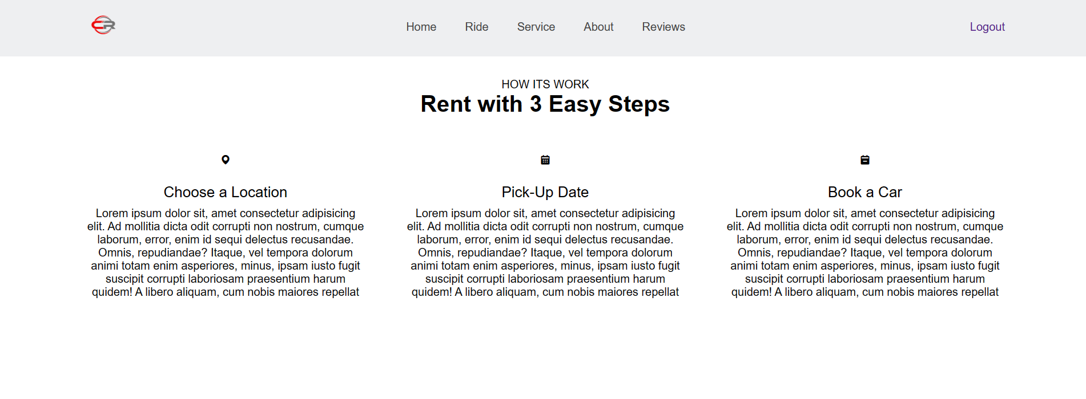

* 1. **Services**

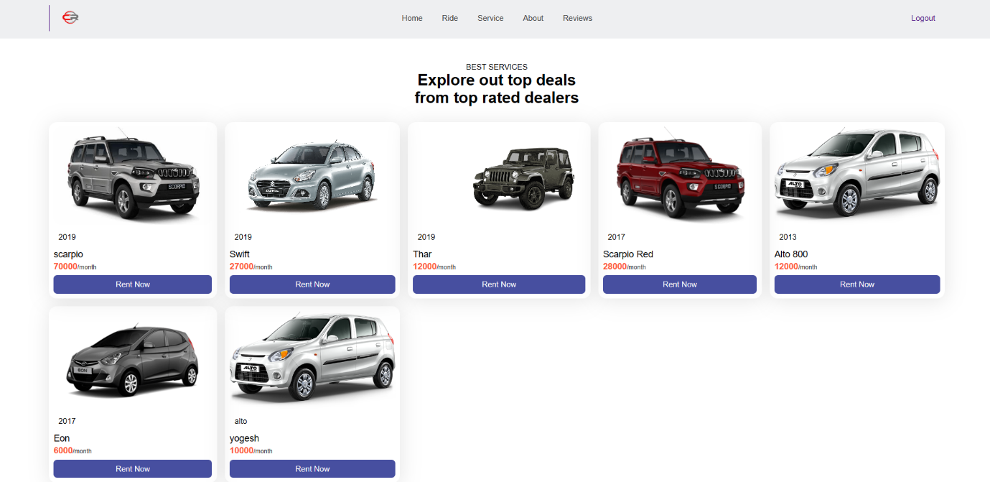

* 1. **About**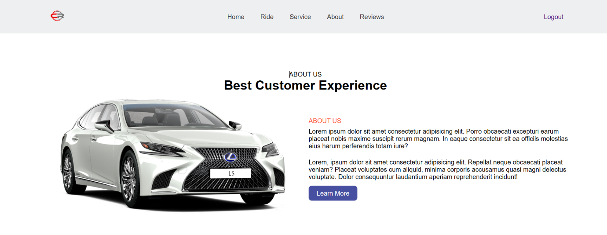
  2. **Review**

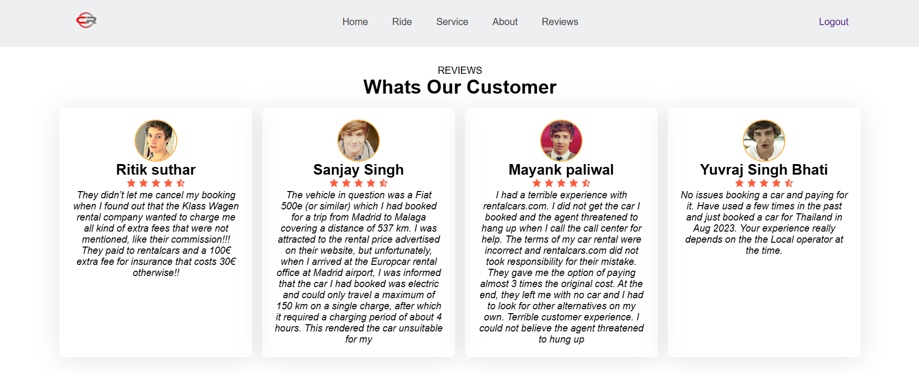

* 1. **Source Code**

**User panel**

1.11.php

<?php

session_start();

?>

<!DOCTYPE html>

<html lang="en">

<head>

<meta charset="UTF-8">

<meta http-equiv="X-UA-Compatible" content="IE=edge">

<meta name="viewport" content="width=device-width, initial-scale=1.0">

<title>Car Rental </title>

<link rel="stylesheet" href="style.css">

<link rel="stylesheet"

href="https://cdn.jsdelivr.net/npm/boxicons@latest/css/boxicons.min.css">

</head>

<body>

<!-- header-->

<header>

<a href="#a" class="logo"><img src="image/ln.png" alt="" style="height: 50px; width: 90px;"></a>

<div class="bx bx-menu" id="menuicon">

</div>

<ul class="navbar">

<li><a href="#home">Home</a></li>

<li><a href="#ride">Ride</a></li>

<li><a href="#services">Service</a></li>

<li><a href="#about">About</a></li>

<li><a href="#reviews">Reviews</a></li>

</ul>

<?php

if(isset($_SESSION["userid"])){

?>

<div class="header_btn">

<a href="loginandsignup\logout.php" class="sign_up">Logout</a>

</div>

<?php } else{ ?>

<div class="header_btn">

<a href="loginandsignup/rgs.html" class="sign_up">Sign Up</a>

<a href="loginandsignup/signup.php" class="sign_in">Sign In</a>

</div>

<?php } ?>

</header>

<!--Home-->

<div class="hero">

<section class="home" id="home">

<div class="text">

<h1><span>Looking</span> to <br>rent a car </h1>

<p><b>

Lorem ipsum dolor sit amet consectetur</p></b>

<div class="app-stores">

<img src="image/download(2).png">

<!--- <img src="assests/IMG/googlePlay.png" height="60vh">-->

</div>

</div>

<div class="form-container">

<form action="detail.php" method="Post">

<div class="input-box">

<span>Location</span>

<input type="search" name="location" placeholder="Search Places">

</div>

<div class="input-box">

<span>Pick Up Date</span>

<input type="date" name="Date" id="">

</div>

<div class="input-box">

<span>Return Date</span>

<input type="date" name="Rdate" id="">

</div>

<input type="submit" name="" class="btn">

</form>

</div>

</section>

<!-- ride-->

<section class="ride" id="ride">

<div class="heading">

<span>How Its Work</span>

<h1>Rent with 3 Easy Steps</h1>

<div class="ridecointer">

<div class="box">

<i class='bx bxs-map'></i>

<h2>Choose a Location</h2>

<p>Lorem ipsum dolor sit, amet consectetur adipisicing elit. Ad mollitia dicta odit corrupti non nostrum, cumque laborum, error, enim id sequi delectus recusandae. Omnis, repudiandae? Itaque, vel tempora dolorum animi totam enim asperiores, minus, ipsam iusto fugit suscipit corrupti laboriosam praesentium harum quidem! A libero aliquam, cum nobis maiores repellat </p>

</div>

<div class="box">

<i class='bx bxs-calendar'></i>

<h2>Pick-Up Date</h2>

<p>Lorem ipsum dolor sit, amet consectetur adipisicing elit. Ad mollitia dicta odit corrupti non nostrum, cumque laborum, error, enim id sequi delectus recusandae. Omnis, repudiandae? Itaque, vel tempora dolorum animi totam enim asperiores, minus, ipsam iusto fugit suscipit corrupti laboriosam praesentium harum quidem! A libero aliquam, cum nobis maiores repellat </p>

</div>

<div class="box">

<i class='bx bxs-calendar-minus' ></i>

<h2>Book a Car</h2>

<p>Lorem ipsum dolor sit, amet consectetur adipisicing elit. Ad mollitia dicta odit corrupti non nostrum, cumque laborum, error, enim id sequi delectus recusandae. Omnis, repudiandae? Itaque, vel tempora dolorum animi totam enim asperiores, minus, ipsam iusto fugit suscipit corrupti laboriosam praesentium harum quidem! A libero aliquam, cum nobis maiores repellat</p>

</div>

</div>

</div>

</section>

<!--Services -->

<section class="services" id="services">

<div class="heading">

<span>Best Services</span>

<h1>Explore out top deals <br> from top rated dealers</h1></center>

</div>

<div class="services-container">

<?php

$connn=mysqli_connect("localhost","root","","carrentaldata");

$r=mysqli_query($connn,"select * from uploadcar");

while($row=mysqli_fetch_array($r)){

?>

<div class="box">

<div class="box-img">

<img src="admin/carphoto/<?php echo $row[1];?>" alt="">

</div>

<p id="phu"><?php echo $row[2]; ?></p>

<h3><?php echo $row[3]; ?></h3>

<h2><?php echo $row[4]; ?><span>/month</span></h2>

<a href="car1.php?a=<?php echo $row[0]; ?> "class="btn">Rent Now</a>

</div>

<?php } ?>

</div>

</section>

<!--expensive-->

<?php

$con=mysqli_connect("localhost","root","","carrentaldata");

$r=mysqli_query($con,"select * from bestofferdata");

while($row=mysqli_fetch_array($r)){

?>

<section class="wrapper top">

<div class="scontainer">

<div class="text">

<p>Best Offer</p>

<h1><?php echo $row[1]; ?></h1>

<p><?php echo $row[2]; ?></p>

<h3><?php echo $row[3]; ?>/Month</h3>

<a class="btn2" href="car3.php?a=<?php echo $row[0];?>">Rent know</a>

</div>

<div class="ani_image">

<img id="in" src="admin/bestofphoto/<?php echo $row[4];?>" alt="">

</div>

</div>

</section>

<?php } ?>

<!--About-->

<section class="about" id="about">

<div class="heading">

<span>About us</span>

<h1>Best Customer Experience</h1>

</div>

<div class="about-cointainer">

<div class="about-img">

<img src="image/lexus.png" alt="">

</div>

<div class="about-text">

<span>About us</span>

<p>The “Car Rental Website” has been developed to override the problem rent a car and Get a rented car sitting at home manual system. This website supported in almost every browser. This website designed for make car rent need of the provide rented car to user in a smooth and effective manner.

</p>

<p>

This website is reduced as much as possible to avoid errors while entering the data. No format knowledge is needed for the user to use this website. Thus by this all it proves it is user-friendly. Car rental website, as described above, can lead to error free, reliable and fast management system. It can assist the user to concentrate on their other activities rather to concentrate on the record keeping. Thus it will help user to rent car in better utilization of resources.

</p>

<a href="#" class="btn">Learn More</a>

</div>

</div>

</section>

<!--reviews-->

<section class="reviews" id="reviews">

<div class="heading">

<span>Reviews</span>

<h1>Whats Our Customer</h1>

</div>

<div class="reviews-cotainer">

<?php

$con=mysqli_connect("localhost","root","","carrentaldata");

$r=mysqli_query($con,"select * from reviewdata");

while($row=mysqli_fetch_array($r)){

?>

<div class="box">

<div class="rev-image">

<img src="admin/reviewphoto/<?php echo $row[1];?>" alt="">

</div>

<h2><?php echo $row[2]; ?></h2>

<div class="star">

<i class='bx bxs-star' ></i>

<i class='bx bxs-star' ></i>

<i class='bx bxs-star' ></i>

<i class='bx bxs-star' ></i>

<i class='bx bxs-star-half' ></i>

</div>

<p><?php echo $row[3]; ?></p>

</div>

<?php } ?>

</section>

<!--newslater-->

<section class="newsletter">

<h2>Subscribe to Newsletter</h2>

<div class="box">

<input type="text" placeholder="Enter your Email...">

<a href="#" class="btn">Subscribe</a>

</div>

</section>

<!--copyright-->

<div class="copyright">

<p>&#169; CarRental All Right Reserved</p>

<div class="soical">

<a href="#"><i class='bx bxl-facebook' ></i></a>

<a href="#"><i class='bx bxl-instagram' ></i></a>

<a href="#"><i class='bx bxl-twitter' ></i></a>

</div>

</div>

<!--scroll revel-->

<script src="https://unpkg.com/scrollreveal"></script>

<!--link js-->

<script src="main.js"></script>

**2.register/login.php**

<!DOCTYPE html>

<html lang="en">

<head>

<meta charset="UTF-8">

<meta http-equiv="X-UA-Compatible" content="IE=edge">

<meta name="viewport" content="width=device-width, initial-scale=1.0">

<title>Document</title>

<link rel="stylesheet" href="signup.css">

</head>

<body>

<div class="container">

<div class="row">

<img src="../image/login.jpg" alt="img" class="img">

</div>

<div class="row">

<form action="next.php" class="form active" id="login" method="post">

<h2>Register</h2>

<label for="name">Name</label>

<div class="pass-reset" onclick="activeInput(this)">

<input type="text" name="name" class="name" id="nameInput" placeholder="Enter Full Name">

</div>

<label for="city">City</label>

<div class="pass-reset" onclick="activeInput(this)">

<input type="text" name="city" class="city" id="cityInput" placeholder="Enter City">

</div>

<label for="email">Email Address</label>

<div class="pass-reset" onclick="activeInput(this)">

<input type="email" name="email" class="email" id="emailInput" placeholder="name@mail.com">

</div>

<label for="password">Password</label>

<div class="pass-reset" onclick="activeInput(this)">

<input type="password" class="password" name="password" id="password" placeholder="**********">

</div>

<label for="cpassword">Conform Password</label>

<div class="pass-reset" onclick="activeInput(this)">

<input type="password" class="cpassword" name="cpassword" id="cpasswordinput" placeholder="**********">

</div>

<div class="pass-reset remember-box">

<input type="checkbox" name="remember" class="remember" id="remember"><span class="remember-text">Rememeber Password</span>

</div>

<button class="btn btn-login">Register</button>

<p> have an account? <a href="signup.html" onclick="changeToRegister()" id="changeToRegister">Login</a></p>

<p class="or"></p>

</form>

</body>

</html>

**3.logout.php**

<?php

session_start();

session_destroy();

header("location:signup.php");

?>

**5.Carrent.php**

<?php

session_start();

?>

<!DOCTYPE html>

<html lang="en">

<head>

<meta charset="UTF-8">

<meta http-equiv="X-UA-Compatible" content="IE=edge">

<meta name="viewport" content="width=device-width, initial-scale=1.0">

<title>Document</title>

<link rel="stylesheet" href="style.css">

</head>

<style>

body{

}

.image img{

width: 800px;

height:500px;

}

.container{

display:flex;

justify-content: space-around;

}

.table{

display:flex;

justify-content: space-around;

align-items: center;

/* border :2px solid grey; */

/* padding: 30px; */

}

table{

margin: 5px;

}

.table tr ,td{

border :2px solid grey;

padding: 10px;

background-color: lightblue;

}

.btn{

display: flex;

justify-content: center;

align-items: flex-end;

position: relative;

top: 150px;

padding:10px;

}

.btn button{

padding:10px;

border-radius:10px;

background-color: transparent;

}

h2{

text-align: center;

}

.bttn{

padding:10px;

border-radius:10px;

box-shadow:0px 0px 0px 10px;

background-color:#eaeef7;

}

</style>

<body>

<!-- header-->

<header>

<a href="#a" class="logo"><img src="image/ln.png" alt="" style="height: 50px; width: 90px;"></a>

<div class="bx bx-menu" id="menuicon">

</div>

<ul class="navbar">

<li><a href="index1.php">Home</a></li>

<li><a href="index1.php">Ride</a></li>

<li><a href="index1.php">Service</a></li>

<li><a href="index1.php">About</a></li>

<li><a href="index1.php">Reviews</a></li>

</ul>

<?php

if(isset($_SESSION["userid"])){

?>

<div class="header_btn">

<a href="loginandsignup\logout.php" class="sign_up">Logout</a>

</div>

<?php } else{ ?>

<div class="header_btn">

<a href="loginandsignup/rgs.html" class="sign_up">Sign Up</a>

<a href="loginandsignup/signup.php" class="sign_in">Sign In</a>

</div>

<?php } ?>

</header>

<div class="container">

<?php

$connn=mysqli_connect("localhost","root","","carrentaldata");

$id=$_REQUEST["a"];

$r=mysqli_query($connn,"select * from uploadcar where id='$id'");

while($row=mysqli_fetch_array($r)){

?>

<div class="image" style="margin-top: 91px;">

<img style="

margin-left: -61px;

" src="admin/carphoto/<?php echo $row[1];?>" alt="">

</div>

<div class="details" style="margin-top: 63px;">

<H2 style="margin-top: 76px; color: black; font-size: xx-large; font-style: unset;"><?php echo $row[3]; ?></H2>

<h3 style="margin-top:20px;">Engine</h3>

<div class="table">

<table class="table table-bordered" style="margin-top:10px;">

<tr>

<td class="key" >Type</td>

<td><?php echo $row[5]; ?></td>

</tr>

<tr>

<td class="key">Total Displacement</td>

<td><?php echo $row[6]; ?></td>

</tr>

<tr>

<td class="key">Power</td>

<td><?php echo $row[7]; ?></td>

</tr>

<tr>

<td class="key">Torque</td>

<td><?php echo $row[8]; ?></td>

</tr>

<tr>

<td class="key">Length</td>

<td><?php echo $row[9]; ?>mm</td>

</tr>

</table>

<table>

<tr>

<td class="key">Width</td>

<td><?php echo $row[10]; ?>mm</td>

</tr>

<tr>

<td class="key">Height</td>

<td><?php echo $row[11]; ?>mm</td>

</tr>

<tr>

<td class="key">Wheelbase</td>

<td><?php echo $row[12]; ?>mm</td>

</tr>

<tr>

<td class="key">Boot Capacity</td>

<td><?php echo $row[13]; ?>mm</td>

</tr>

<tr>

<td class="key">Feul Tank</td>

<td><?php echo $row[14]; ?>ltr</td>

</tr>

</table>

</div>

</div>

</div>

<div class="header_btn" style="margin-top: 65px;">

<?php

if(isset($_SESSION["userid"]))

{

?>

<button ><a class="bttn" href="rentcarknow/rentcarknow.php?a=<?php echo $row[0];?>" style="text-decoration: none;">Rent Now</a></button>

<?php } else {?>

</div>

<button style="

margin-left: 48%;

" ><a href="loginandsignup/signup.php" style="text-decoration: none;">Rent Now</a></button>

<?php }} ?>

<div class="copyright" style="

margin-top: 24px;

background: bottom;

background-color: #c4b9b9;

padding : 5px;

justify-content:center;

">

<p>&#169; CarRental All Right Reserved</p>

</div>

</body>

</html>

**6.Main.js**

let menu = document.querySelector('#menuicon');

let navbar = document.querySelector('.navbar');

menu.onclick = () => {

menu.classList.toggle('bx-x');

navbar.classList.toggle('active');

}

window.onscroll = () => {

menu.classList.remove('bx-x');

navbar.classList.remove('active');

}

const sr = ScrollReveal ({

distance: '60px',

duration: 2500,

delay: 400,

reset: true

})

sr.reveal('.text',{delay: 300, origin: 'top'})

sr.reveal('.form-container form',{delay: 300, origin: 'left'})

sr.reveal('.heading',{delay: 800, origin: 'top'})

sr.reveal('.ridecointer .box',{delay: 300, origin: 'top'})

sr.reveal('.services-container .box',{delay: 300, origin: 'top'})

sr.reveal('.about-cointainer .box',{delay: 300, origin: 'top'})

sr.reveal('.reviews-cotainer .box',{delay: 300, origin: 'top'})

sr.reveal('.newsletter .box',{delay: 200, origin: 'bottom'})

**7.Car.php**

<?php

$carmodel =$_POST["carmodel"];

$carname=$_POST["carname"];

$carrent=$_POST["car_rent"];

$type=$_POST["type"];

$displacemet=$_POST["totald"];

$maxpower=$_POST["power"];

$torque=$_POST["torque"];

$length=$_POST["length"];

$width=$_POST["width"];

$height=$_POST["height"];

$weelbase=$_POST["wheelbase"];

$bootcapacity=$_POST["bootcap"];

$fuel=$_POST["fueltank"];

$r=move_uploaded_file($_FILES["aa"]["tmp_name"],"carphoto/".$_FILES["aa"]["name"]);

$pname=$_FILES["aa"]["name"];

$con=mysqli_connect("localhost","root","","Carrentaldata");

$rr=mysqli_query($con,"insert into uploadcar (Image,Model,Name,Rents,Type,Totaldisplacement,power,torque,length,width,height,wheelbase,bootcapacity,fueltank) values ('$pname','$carmodel','$carname',

'$carrent','$type','$displacemet','$maxpower','$torque','$length','$width','$height','$weelbase','$bootcapacity','$fuel')");

if($rr){

header("location:cardata.html");

}

else

echo mysqli_error($con);

?>

**8.bestoffer.php**

<?php

$carname =$_POST["carmodel"];

$discription=$_POST["carname"];

$carrent=$_POST["car_rent"];

$type=$_POST["type"];

$displacemet=$_POST["totald"];

$maxpower=$_POST["power"];

$torque=$_POST["torque"];

$length=$_POST["length"];

$width=$_POST["width"];

$height=$_POST["height"];

$weelbase=$_POST["wheelbase"];

$bootcapacity=$_POST["bootcap"];

$fuel=$_POST["fueltank"];

$r=move_uploaded_file($_FILES["aa"]["tmp_name"],"bestofphoto/".$_FILES["aa"]["name"]);

$pname=$_FILES["aa"]["name"];

$con=mysqli_connect("localhost","root","","carrentaldata");

$rr=mysqli_query($con,"insert into bestofferdata (carname,discription,rate,photo,type,displacement,maxpower,torque,length,width,height,weelbase,bootcapacity,fuel) values ('$carname','$discription','$carrent',

'$pname','$type','$displacemet','$maxpower','$torque','$length','$width','$height','$weelbase','$bootcapacity','$fuel')");

if($rr){

header("location:bestoffer.html");

}

else

echo mysqli_error($con);

?>

**Admin panel**

1.11.php

<?php

session_start();

?>

<!DOCTYPE html>

<html lang="en">

<head>

<meta charset="UTF-8">

<meta http-equiv="X-UA-Compatible" content="IE=edge">

<meta name="viewport" content="width=, initial-scale=1.0">

<title>Document</title>

<link rel="stylesheet" href="admin page/main.css">

<style>

a{

text-transform:uppercase;

font-size:11pt;

text-decoration:none;

}

</style>

<meta charset="utf-8">

<meta name="viewport" content="width=device-width, initial-scale=1">

<link href="https://cdn.jsdelivr.net/npm/bootstrap@5.2.3/dist/css/bootstrap.min.css" rel="stylesheet">

<script src="https://cdn.jsdelivr.net/npm/bootstrap@5.2.3/dist/js/bootstrap.bundle.min.js"></script>

<link rel="stylesheet" href="https://cdn.datatables.net/1.13.4/css/jquery.dataTables.min.css"/>

</head>

<body style="background-image: url(image/GradeLevelWelcome11.jpg); background-repeat: no-repeat; background-size: cover;">

<!--Header-->

<header style="width: 110%; ">

<a href="#" class="logo"><img src="assests/images/1-removebg-preview.png" alt=""></a>

<ul class="navbar">

<li><a href="admin/cardata.php">ADD CAR</a></li>

<li><a href="admin/reviewform.php">ADD REVIEW</a></li>

<li><a href="admin/Bestoffee.php">BEST OFFER</a></li>

<li><a href="admin/admin.php">USER DATA</a></li>

<li><a href="admin/viewcardata.php">Car data</a></li>

<li><a href="admin/viewbest.php">Best offer data</a></li>

<li><a href="admin/reviewdata.php">review data</a></li>

<li><a href="rentcarknow/viewuserdata.php">car booking</a></li>

<?php

if(isset($_SESSION["userid"])){

?>

<div class="header_btn">

<li> <a href="loginandsignup\adminlogout.php" class="sign_up">Logout</a></li>

</div>

<?php } else{ ?>

<div class="header_btn">

<li><a href="loginandsignup/adminlogin.php" class="sign_in">Sign In</a></li>

</div>

<?php } ?>

</ul>

</header>

</body>

</html>

**2.Addcar.php**

<?php

session_start();

?>

<!DOCTYPE html>

<html lang="en">

<head>

<meta charset="UTF-8">

<meta http-equiv="X-UA-Compatible" content="IE=edge">

<meta name="viewport" content="width=device-width, initial-scale=1.0">

<title>Document</title>

<style>

body

{

width: 100vw;

height: 100%;

}

form

{

/* display: flex;

justify-content: center;

align-items: center; */

display: grid;

place-items: center;

margin-top: 10%;

}

/* tr

{

padding: 4px;

} */

td{

padding: 20px;

}

footer{

height:330px;

display:flex;

justify-content: center;

align-items: flex-end;

}

.author{

background-color:#c9cbd0 ;

color: #100f0f;

height: 50px;

width: 100%;

text-align: center;

padding: 11px;

}

a{

text-transform:uppercase;

font-size:11pt;

text-decoration:none;

}

</style>

<meta charset="utf-8">

<meta name="viewport" content="width=device-width, initial-scale=1">

<link href="https://cdn.jsdelivr.net/npm/bootstrap@5.2.3/dist/css/bootstrap.min.css" rel="stylesheet">

<script src="https://cdn.jsdelivr.net/npm/bootstrap@5.2.3/dist/js/bootstrap.bundle.min.js"></script>

<link rel="stylesheet" href="../admin page/main.css">

</head>

<body>

<!--Header-->

<header style="width: 110%; ">

<a href="#" class="logo"><img src="assests/images/1-removebg-preview.png" alt=""></a>

<ul class="navbar">

<li><a href="cardata.php">Add car</a></li>

<li><a href="reviewform.php">Add review</a></li>

<li><a href="Bestoffe.php">Best offer</a></li>

<li><a href="admin.php">user data</a></li>

<li><a href="viewcardata.php">Car data</a></li>

<li><a href="viewbest.php">Best offer data</a></li>

<li><a href="reviewdata.php">review data</a></li>

<li><a href="../rentcarknow/viewuserdata.php">Car Booking</a></li>

<?php

if(isset($_SESSION["userid"])){

?>

<div class="header_btn">

<li> <a href="../loginandsignup\adminlogout.php" class="sign_up">Logout</a></li>

</div>

<?php } else{ ?>

<div class="header_btn">

<li><a href="../loginandsignup/adminlogin.php" class="sign_in">Sign In</a></li>

</div>

<?php } ?> </ul>

</header>

<div style="width:700px;margin:auto;margin-top:120px;">

<center><H2>ADD CAR</H2></center>

<form action="car.php" method="post" class="" enctype="multipart/form-data">

<table cellspacing="0" cellpadding="10" class="table table-bordered" align="center" border="2px" >

<tr>

<td>Image</td>

<td><input type="file" class="form-control" value="Select image" name="aa" required></td>

</tr>

<tr>

<td>Car Model</td>

<td><input type="text" class="form-control" name="carmodel" placeholder="Enter car name" required /></td>

</tr>

<tr>

<td>

Car Name

</td>

<td><input type="text" class="form-control" name="carname" placeholder="Enter name" required /></td>

</tr>

<tr>

<td>

Car Rent

</td>

<td>

<input type="text" class="form-control" name="car_rent" placeholder="Enter rent" required/>

</td>

</tr>

<tr>

<td>Engine</td>

</tr>

<tr>

<td>Type</td>

<td>

<input type="text" class="form-control" name="type" id="" placeholder="Engine type" required>

</td>

</tr>

<tr>

<td>Total displacement</td>

<td>

<input type="text" class="form-control" name="totald" id="" placeholder="displacement" required>

</td>

</tr>

<tr>

<td>Maximun Power*</td>

<td><input type="text" class="form-control" name="power" id="" placeholder="Enter max power" required></td>

</tr>

<tr>

<td>Maximum torque</td>

<td><input type="text" class="form-control" name="torque" id="" placeholder="Enter torque" required></td>

</tr>

<tr>

<td>Dimensions And weight</td>

</tr>

<tr>

<td>

Length

</td>

<td><input type="number" class="form-control" name="length" id="" placeholder="Enter length" required></td>

</tr>

<tr>

<td>width</td>

<td><input type="number" class="form-control" name="width" id="" placeholder="Enter width" required></td>

</tr>

<tr>

<td>Height</td>

<td><input type="number" class="form-control" name="height" id="" placeholder="Enter Height" required></td>

</tr>

<tr>

<td>Wheelbase</td>

<td><input type="number" class="form-control" name="wheelbase" id="" placeholder="Enter Wheelbase" required></td>

</tr>

<tr>

<td>Boot capacity</td>

<td><input type="number" class="form-control" name="bootcap" placeholder="Enter boot capacity" id="" required></td>

</tr>

<tr>

<td>

Fuel Tank Capacity

</td>

<td><input type="number" class="form-control" name="fueltank" id="" placeholder="Enter Tank Capacity" required></td>

</tr>

<tr id="last">

<td style="text-align: center;" colspan="2"><input type="submit" class="btn btn-primary"

name="submit" value="submit" /> </td>

</tr>

</table>

</form>

</div>

<footer>

<div class="author">

<p>© CarRental All Right Reserved</p>

</div>

</footer>

</body>

</html>

**3.Review.php**

<?php

$name=$_POST["name"];

$comment=$_POST["comment"];

$r=move_uploaded_file($_FILES["aa"]["tmp_name"],"reviewphoto/".$_FILES["aa"]["name"]);

$pname=$_FILES["aa"]["name"];

$con=mysqli_connect("localhost","root","","carrentaldata");

$rr=mysqli_query($con,"insert into reviewdata (image,name,comment) values ('$pname','$name','$comment')");

if($rr)

echo "insert";

else

echo mysqli_error($con);

?>

**4.Reviewform.php**

<?php

session_start();

?>

<!DOCTYPE html>

<html lang="en">

<head>

<meta charset="UTF-8">

<meta http-equiv="X-UA-Compatible" content="IE=edge">

<meta name="viewport" content="width=device-width, initial-scale=1.0">

<title>Document</title>

<link rel="stylesheet" href="../admin page/main.css">

<script src="https://code.jquery.com/jquery-3.5.1.js"></script>

<script src="https://cdn.datatables.net/1.13.4/js/jquery.dataTables.min.js"></script>

<script>

$(document).ready(function () {

$('#example').DataTable();

});

</script>

<style>

footer{

height:385px;

display:flex;

justify-content: center;

align-items: flex-end;

}

.author{

background-color:#c9cbd0 ;

color: #100f0f;

height: 50px;

width: 120%;

text-align: center;

padding: 11px;

}

a{

text-transform:uppercase;

font-size:11pt;

text-decoration:none;

}

</style>

<meta charset="utf-8">

<meta name="viewport" content="width=device-width, initial-scale=1">

<link href="https://cdn.jsdelivr.net/npm/bootstrap@5.2.3/dist/css/bootstrap.min.css" rel="stylesheet">

<script src="https://cdn.jsdelivr.net/npm/bootstrap@5.2.3/dist/js/bootstrap.bundle.min.js"></script>

<link rel="stylesheet" href="https://cdn.datatables.net/1.13.4/css/jquery.dataTables.min.css"/>

</head>

<body>

<!--Header-->

<header style="width: 110%; ">

<a href="#" class="logo"><img src="assests/images/1-removebg-preview.png" alt=""></a>

<ul class="navbar">

<li><a href="cardata.php">Add car</a></li>

<li><a href="reviewform.php">Add review</a></li>

<li><a href="Bestoffe.php">Best offer</a></li>

<li><a href="admin.php">user data</a></li>

<li><a href="viewcardata.php">Car data</a></li>

<li><a href="viewbest.php">Best offer data</a></li>

<li><a href="reviewdata.php">review data</a></li>

<li><a href="../rentcarknow/viewuserdata.php">car booking</a></li>

<?php

if(isset($_SESSION["userid"])){

?>

<div class="header_btn">

<li> <a href="../loginandsignup\adminlogout.php" class="sign_up">Logout</a></li>

</div>

<?php } else{ ?>

<div class="header_btn">

<li><a href="../loginandsignup/adminlogin.php" class="sign_in">Sign In</a></li>

</div>

<?php } ?></ul>

</header>

</body>

</html>

<div clas='container'>

<div style="width:98%;margin:auto;margin-top:7%">

<center><H2>REVIEW DATA</H2> </center>

<?php

$con=mysqli_connect("localhost","root","","carrentaldata");

$r=mysqli_query($con,"select * from reviewdata");

echo "<table border='1' id='example' class='display' align='center' cellspacing=1 cellpadding=10>";

echo "<thead><tr><th>Id</th><th>Photo</th><th>Name</th><th>Comment</th><th>Delete</th></tr></thead><tbody>";

while ($row=mysqli_fetch_array($r)) {

$en=base64_encode($row[0]);

echo"<tr><td>",$row[0],"</td>";

echo "<td><image src='reviewphoto/$row[1]' height=100 width=100></td>";

echo"<td>",$row[2],"</td>";

echo"<td>",$row[3],"</td>";

echo "<td><a href='reviewdatadelete.php?a=$en'>Delete</a></td></tr>";

}

?>

</tbody>

</table>

</div>

<footer>

<div class="author">

<p>© CarRental All Right Reserved</p>

</div>

</footer>

**5.ViewBest.php**

<?php

session_start();

?>

<!DOCTYPE html>

<html lang="en">

<head>

<meta charset="UTF-8">

<meta http-equiv="X-UA-Compatible" content="IE=edge">

<meta name="viewport" content="width=device-width, initial-scale=1.0">

<title>Document</title>

<link rel="stylesheet" href="../admin page/main.css">

<script src="https://code.jquery.com/jquery-3.5.1.js"></script>

<script src="https://cdn.datatables.net/1.13.4/js/jquery.dataTables.min.js"></script>

<style>

footer{

height:158px;

display:flex;

justify-content: center;

align-items: flex-end;

}

.author{

background-color:#c9cbd0 ;

color: #100f0f;

height: 50px;

width: 120%;

text-align: center;

padding: 11px;

}

a{

text-transform:uppercase;

font-size:11pt;

text-decoration:none;

}

</style>

<script>

$(document).ready(function () {

$('#example').DataTable();

});

</script>

<meta charset="utf-8">

<meta name="viewport" content="width=device-width, initial-scale=1">

<link href="https://cdn.jsdelivr.net/npm/bootstrap@5.2.3/dist/css/bootstrap.min.css" rel="stylesheet">

<script src="https://cdn.jsdelivr.net/npm/bootstrap@5.2.3/dist/js/bootstrap.bundle.min.js"></script>

<link rel="stylesheet" href="https://cdn.datatables.net/1.13.4/css/jquery.dataTables.min.css"/>

</head>

<body>

<!--Header-->

<header style="width: 110%; ">

<a href="#" class="logo"><img src="assests/images/1-removebg-preview.png" alt=""></a>

<ul class="navbar">

<li><a href="cardata.php">Add car</a></li>

<li><a href="reviewform.php">Add review</a></li>

<li><a href="Bestoffe.php">Best offer</a></li>

<li><a href="admin.php">user data</a></li>

<li><a href="viewcardata.php">Car data</a></li>

<li><a href="viewbest.php">Best offer data</a></li>

<li><a href="reviewdata.php">review data</a></li>

<li><a href="../rentcarknow/viewuserdata.php">car Booking</a></li>

<?php

if(isset($_SESSION["userid"])){

?>

<div class="header_btn">

<li> <a href="../loginandsignup\adminlogout.php" class="sign_up">Logout</a></li>

</div>

<?php } else{ ?>

<div class="header_btn">

<li><a href="../loginandsignup/adminlogin.php" class="sign_in">Sign In</a></li>

</div>

<?php } ?></ul>

</header>

</body>

</html>

<div clas='container'>

<div style="width:98%;margin:auto;margin-top:7%">

<center><h2>BEST OFFER DATA</h2></center>

<?php

$connn=mysqli_connect("localhost","root","","carrentaldata");

$rrr=mysqli_query($connn,"select * from bestofferdata");

echo " <table border='1' id='example' class='display' align='center' cellspacing=1 cellpadding=20>";

echo "<thead><tr><th>Id</th><th>Photo</th><th>Name</th><th>Discription</th><th>Rent</th><th>Type</th><th>Total Displacement</th><th>Maximum Power</th>

<th>Maximum Torque</th><th>Length</th><th>Width</th><th>Height</th><th>WheelBase</th><th>Boot Capacity</th><th>Fuel Tank</th><th>Delete</th><th>Edit</th></tr></thead><tbody>";

while ($rowww=mysqli_fetch_array($rrr)) {

$enn=base64_encode($rowww[0]);

echo "<tr><td>",$rowww[0],"</td>";

echo "<td><image src='bestofphoto/$rowww[4]' height=100 width=100></td>";

echo "<td>",$rowww[1],"</td>";

echo "<td>",$rowww[2],"</td>";

echo "<td>",$rowww[3],"</td>";

echo "<td>",$rowww[5],"</td>";

echo "<td>",$rowww[6],"</td>";

echo "<td>",$rowww[7],"</td>";

echo "<td>",$rowww[8],"</td>";

echo "<td>",$rowww[9],"</td>";

echo "<td>",$rowww[10],"</td>";

echo "<td>",$rowww[11],"</td>";

echo "<td>",$rowww[12],"</td>";

echo "<td>",$rowww[13],"</td>";

echo "<td>",$rowww[14],"</td>";

echo "<td><a href='deletebest.php?b=$enn'>Delete</a></td>";

echo "<td><a href='editbest.php?a=$rowww[0]'>Edit</a></td></tr>";

}

?>

</tbody>

</table>

</div>

<footer>

<div class="author">

<p>© CarRental All Right Reserved</p>

</div>

</footer>

**6.Viewcar.php**

<?php

session_start();

?>

<!DOCTYPE html>

<html lang="en">

<head>

<meta charset="UTF-8">

<meta http-equiv="X-UA-Compatible" content="IE=edge">

<meta name="viewport" content="width=device-width, initial-scale=1.0">

<title>Document</title>

<link rel="stylesheet" href="../admin page/main.css">

<script src="https://code.jquery.com/jquery-3.5.1.js"></script>

<script src="https://cdn.datatables.net/1.13.4/js/jquery.dataTables.min.js"></script>

<style>

footer{

height:385px;

display:flex;

justify-content: center;

align-items: flex-end;

}

.author{

background-color:#c9cbd0 ;

color: #100f0f;

height: 50px;

width: 120%;

text-align: center;

padding: 11px;

}

a{

text-transform:uppercase;

font-size:11pt;

text-decoration:none;

}

</style>

<script>

$(document).ready(function () {

$('#example').DataTable();

});

</script>

<meta charset="utf-8">

<meta name="viewport" content="width=device-width, initial-scale=1">

<link href="https://cdn.jsdelivr.net/npm/bootstrap@5.2.3/dist/css/bootstrap.min.css" rel="stylesheet">

<script src="https://cdn.jsdelivr.net/npm/bootstrap@5.2.3/dist/js/bootstrap.bundle.min.js"></script>

<link rel="stylesheet" href="https://cdn.datatables.net/1.13.4/css/jquery.dataTables.min.css"/>

</head>

<body>

<header style="width: 110%; ">

<a href="#" class="logo"><img src="assests/images/1-removebg-preview.png" alt=""></a>

<ul class="navbar">

<li><a href="cardata.php">Add car</a></li>

<li><a href="reviewform.php">Add review</a></li>

<li><a href="Bestoffe.php">Best offer</a></li>

<li><a href="admin.php">user data</a></li>

<li><a href="viewcardata.php">Car data</a></li>

<li><a href="viewbest.php">Best offer data</a></li>

<li><a href="reviewdata.php">review data</a></li>

<li><a href="../rentcarknow/viewuserdata.php">car booking</a></li>

<?php

if(isset($_SESSION["userid"])){

?>

<div class="header_btn">

<li> <a href="../loginandsignup\adminlogout.php" class="sign_up">Logout</a></li>

</div>

<?php } else{ ?>

<div class="header_btn">

<li><a href="../loginandsignup/adminlogin.php" class="sign_in">Sign In</a></li>

</div>

<?php } ?></ul>

</header>

</body>

</html>

<div clas='container'>

<div style="width:98%;margin:auto;margin-top:7%">

<center><h2>CAR DATA</h2></center>

<?php

$connn=mysqli_connect("localhost","root","","carrentaldata");

$rrr=mysqli_query($connn,"select * from uploadcar");

echo " <table border='1' id='example' class='display' align='center' cellspacing=0 cellpadding=10>";

echo "<thead><tr><th>Id</th><th>Image</th><th>Model</th><th>Name</th><th>Rent</th><th>Type</th><th>Total Displacement</th><th>Maximum Power</th>

<th>Maximum Torque</th><th>Length</th><th>Width</th><th>Height</th><th>WheelBase</th><th>Boot Capacity</th><th>Fuel Tank</th><th>Delete</th><th>Edit</th></tr></thead><tbody>";

while ($rowww=mysqli_fetch_array($rrr)) {

$enn=base64_encode($rowww[0]);

echo "<tr><td>",$rowww[0],"</td>";

echo "<td><image src='carphoto/$rowww[1]' height=100 width=100></td>";

echo "<td>",$rowww[2],"</td>";

echo "<td>",$rowww[3],"</td>";

echo "<td>",$rowww[4],"</td>";

echo "<td>",$rowww[5],"</td>";

echo "<td>",$rowww[6],"</td>";

echo "<td>",$rowww[7],"</td>";

echo "<td>",$rowww[8],"</td>";

echo "<td>",$rowww[9],"</td>";

echo "<td>",$rowww[10],"</td>";

echo "<td>",$rowww[11],"</td>";

echo "<td>",$rowww[12],"</td>";

echo "<td>",$rowww[13],"</td>";

echo "<td>",$rowww[14],"</td>";

echo "<td><a href='deleteecar.php?c=$enn'>Delete</a></td>";

echo "<td><a href='editcardata.php?c=$rowww[0]'>Edit</a></td></tr>";

}

?>

</tbody>

</table>

</div>

<footer>

<div class="author">

<p>© CarRental All Right Reserved</p>

</div>

</footer>

**8.edit.php**

<?php

ob_start();

$con=mysqli_connect("localhost","root","","Carrentaldata");

$id=$_REQUEST["a"];

$r=mysqli_query($con,"select * from bestofferdata where id='$id'");

$row=mysqli_fetch_row($r)

?>

<head>

<meta charset="UTF-8">

<meta http-equiv="X-UA-Compatible" content="IE=edge">

<meta name="viewport" content="width=device-width, initial-scale=1.0">

<title>Document</title>

<link rel="stylesheet" href="../admin page/main.css">

<script src="https://code.jquery.com/jquery-3.5.1.js"></script>

<script src="https://cdn.datatables.net/1.13.4/js/jquery.dataTables.min.js"></script>

<style>

footer{

height:316px;

display:flex;

justify-content: center;

align-items: flex-end;

}

.author{

background-color:#c9cbd0 ;

color: #100f0f;

height: 50px;

width: 120%;

text-align: center;

padding: 11px;

}

a{

text-transform:uppercase;

font-size:11pt;

text-decoration:none;

}

</style>

<script>

$(document).ready(function () {

$('#example').DataTable();

});

</script>

<meta charset="utf-8">

<meta name="viewport" content="width=device-width, initial-scale=1">

<link href="https://cdn.jsdelivr.net/npm/bootstrap@5.2.3/dist/css/bootstrap.min.css" rel="stylesheet">

<script src="https://cdn.jsdelivr.net/npm/bootstrap@5.2.3/dist/js/bootstrap.bundle.min.js"></script>

<link rel="stylesheet" href="https://cdn.datatables.net/1.13.4/css/jquery.dataTables.min.css"/>

</head>

<body>

<header style="width: 105%; ">

<ul class="navbar">

<li><a href="cardata.html">Add car</a></li>

<li><a href="reviewform.html">Add review</a></li>

<li><a href="Bestoffer.html">Best offer</a></li>

<li><a href="admin.php">user data</a></li>

<li><a href="viewcardata.php">Car data</a></li>

<li><a href="viewbest.php">Best offer data</a></li>

<li><a href="reviewdata.php">review data</a></li>

<li><a href="../rentcarknow/viewuserdata.php">car rent user detail</a></li>

<li><a href="../loginandsignup/adminlogin.php"> Login</a></li>

<li><a href="../loginandsignup/adminlogout.php">Logout</a></li>

</ul>

</header>

<div style="width:700px;margin:auto;margin-top:120px;">

<form action="" method="post" class="" enctype="multipart/form-data">

<table cellspacing="0" cellpadding="10" class="table table-bordered" align="center" border="2px" >

<tr>

<td colspan="2">

<input type="hidden" name="id" value="<?php echo $row[0]; ?>">

</td>

</tr>

<tr>

<td>Car Name</td>

<td><input type="text" class="form-control" name="name" value="<?php echo $row[1]; ?>" /></td>

</tr>

<tr>

<td>Image</td>

<td><input type="file" class="form-control"

value="" name="aa">

<image src='bestofphoto/<?php echo $row[4]; ?>' height=100 width=100>

</td>

<tr>

<td>Car Model</td>

<td><input type="text" class="form-control" value="<?php echo $row[2]; ?>" name="carmodel"/></td>

</tr>

<tr>

<td>

Car Name

</td>

<td><input type="text" class="form-control" name="carname" value="<?php echo $row[1]; ?>" /></td>

</tr>

<tr>

<tr>

<td>

Discription

</td>

<td><input type="text" class="form-control" name="dis" value="<?php echo $row[2]; ?>" /></td>

</tr>

<td>

Car Rent

</td>

<td>

<input type="text" class="form-control" name="car_rent" value="<?php echo $row[3]; ?>" />

</td>

</tr>

<tr>

<td>Engine</td>

</tr>

<tr>

<td>Type</td>

<td>

<input type="text" class="form-control" name="type" id="" value="<?php echo $row[5]; ?>" >

</td>

</tr>

<tr>

<td>Total displacement</td>

<td>

<input type="text" class="form-control" name="totald" id="" value="<?php echo $row[6]; ?>" >

</td>

</tr>

<tr>

<td>Maximun Power*</td>

<td><input type="text" class="form-control" name="power" id="" value="<?php echo $row[7]; ?>" ></td>

</tr>

<tr>

<td>Maximum torque</td>

<td><input type="text" class="form-control" name="torque" id="" value="<?php echo $row[8]; ?>" ></td>

</tr>

<tr>

<td>Dimensions And weight</td>

</tr>

<tr>

<td>

Length

</td>

<td><input type="number" class="form-control" value="<?php echo $row[9]; ?>" name="length" id=""></td>

</tr>

<tr>

<td>width</td>

<td><input type="number" class="form-control" name="width" id="" value="<?php echo $row[10]; ?>" ></td>

</tr>

<tr>

<td>Height</td>

<td><input type="number" class="form-control" name="height" id="" value="<?php echo $row[11]; ?>" ></td>

</tr>

<tr>

<td>Wheelbase</td>

<td><input type="number" class="form-control" name="wheelbase" id="" value="<?php echo $row[12]; ?>" ></td>

</tr>

<tr>

<td>Boot capacity</td>

<td><input type="number" class="form-control" name="bootcap" value="<?php echo $row[13]; ?>" ></td>

</tr>

<tr>

<td>

Fuel Tank Capacity

</td>

<td><input type="number" class="form-control" name="fueltank" id="" value="<?php echo $row[14]; ?>" ></td>

</tr>

</tr>

<tr id="last">

<td style="text-align: center;" colspan="2">

<input type="submit" value="Update"class="btn btn-primary" name="up">

<input type="reset"class="btn btn-primary" value="Cancel">

</td>

</tr>

</table>

</form>

</div>

<footer>

<div class="author">

<p>© CarRental All Right Reserved</p>

</div>

</footer>

</body>

<?php

if(isset($_REQUEST["up"])){

$id=$_REQUEST["id"];

$carname=$_REQUEST["name"];

$discription=$_REQUEST["dis"];

$rent = $_REQUEST["car_rent"];

$type=$_POST["type"];

$displacemet=$_POST["totald"];

$maxpower=$_POST["power"];

$torque=$_POST["torque"];

$length=$_POST["length"];

$width=$_POST["width"];

$height=$_POST["height"];

$weelbase=$_POST["wheelbase"];

$bootcapacity=$_POST["bootcap"];

$fuel=$_POST["fueltank"];

$con=mysqli_connect("localhost","root","","Carrentaldata");

if($_FILES["aa"]["name"]=="")

$r=mysqli_query($con,"update bestofferdata set carname='$carname',discription='$discription',rate='$rent',type='$type',

displacement='$displacemet',maxpower='$maxpower',torque='$torque',length='$length',width='$width',height='$height',

weelbase='$weelbase',bootcapacity='$bootcapacity',fuel='$fuel' where id ='$id'");

else

{

$rr=move_uploaded_file($_FILES["aa"]["tmp_name"],"bestofphoto/".$_FILES["aa"]["name"]);

$pname=$_FILES["aa"]["name"];

$r=mysqli_query($con,"update bestofferdata set carname='$carname',discription='$discription',rate='$rent',photo='$pname',type='$type',

displacement='$displacemet',maxpower='$maxpower',torque='$torque',length='$length',width='$width',height='$height',

weelbase='$weelbase',bootcapacity='$bootcapacity',fuel='$fuel'

where id ='$id'");

}

header("location:viewbest.php");

}?>

**MECHANISMS USED**

**5.1 Testing Mechanisms Used:**

Testing Overview

Software testing is any activity aimed at evaluating an attribute or capability of a program or system and determining that it meets its required results. Although crucial to software quality and widely deployed by programmers and testers, software testing still remains an art, due to limited understanding of the principles of software.

UNIT TESTING

MODULE TESTING

SUB-SYSTEM TESING

SYSTEM TESTING

ACCEPTANCE TESTING

Component Testing

Integration Testing

User Testing

**System Testing**

The testing is an important part of software development. It is the process of finding errors and missing operations and also a complex verification to determine whether the objectives are met and the user requirements are satisfied.

**In Online shopping, testing is carried out in Three Steps:**

1. **UNIT TESTING**

The first includes Unit Testing, where in each module is tested to provide its correctness, validity and also determine any missing operations and to verify whether the objectives have been met. Errors are noted down and corrected immediately. Unit testing is the important and major part of the project. So errors are rectified easily in particular module and program clarity is increased. In entire system is divided into several modules and is developed individually. So unit testing is conducted to individual modules.

1. **INTEGRATION TESTING**

The second step includes Integration Testing. It needs not be the case, the software whose modules run individually and showing perfect results, will also show perfect results when run as a whole. In the individual modules are clipped under this major module and tested again verified the results. This is due to poor interfacing which may result in data being lost across an interface. A module can have inadvertent, adverse effect on any other or on the global data structures, causing serious problems.

1. **VALIDATION**

The final step involves Validation and testing which determines whether the software functions as the user expected. also some modifications were done. In the completion of the project it is satisfied fully by the end user.

**CLIENT SIDE VALIDATION**

Various client side validations are used to ensure on the client side that only valid data is entered. Client side validation saves server time and load to handle invalid data. Some checks imposed are:

* Script in used to ensure those required fields are filled with suitable data only. Maximum lengths of the fields of the forms are appropriately defined.
* Forms cannot be submitted without filling up the mandatory data so that manual mistakes of submitting empty fields that are mandatory can be sorted out at the client side to save the server time and load.
* Tab-indexes are set according to the need and taking into account the ease of user while working with the system.

**SERVER SIDE VALIDATION**

Some checks cannot be applied at client side. Server side checks are necessary to save the system from failing and intimating the user that some invalid operation has been performed or the performed operation is restricted. Some of the server side checks imposed is:

* Server side constraint has been imposed to check for the validity of primary key and foreign key. A primary key value cannot be duplicated. Any attempt to duplicate the primary value results into a message intimating the user about those values through the forms using foreign key can be updated only of the existing foreign key values.
* User is intimating through appropriate messages about the successful operations or exceptions occurring at server side.
* Various Access Control Mechanisms have been built so that one user may not agitate upon another. Access permissions to various types of users are controlled according to the organizational structure. Only permitted users can log on have access according to their category. User- name, passwords and permissions are controlled the server side.

**5.2 Implementation Mechanisms Used:**

In **CAR RENTAL WEBSITE**, Implementation is the stage where the theoretical design is turned into a working system. It is the most crucial stage in achieving a new successful system and in giving confidence on the new system for the users that it works efficiently and effectively.

In **CAR RENTAL WEBSITE**, the project can be implemented only after thorough testing is done and if it is found to work according to the specification.

The implementation phase comprises of several activities. The required hardware and software acquisition is carried out. The system may require some system to be developed.

**FUTURE ENHANCEMENT**

Scope of this project is very broad in terms of other manually taking exams.

Few of them are:-

* This can be used for good result
* Can be used anywhere any time as it is a web based application (user location doesn’t matter

**REFERENCE/BIBLIOGRAPHY**

* FOR PHP

[www.php.net](http://www.php.net)

[www.phpreferencebook.com](http://www.phpreferencebook.com)

[www.w3schools.com](http://www.w3schools.com)

* FOR MySQL

[www.msdn.microsoft.com](http://www.msdn.microsoft.com)

[www.mysql.com](http://www.mysql.com)

* BOOK’S

PHP: The Complete Reference

Professional PHP6

Learning PHP, MySQL and JavaScript

Head First PHP & MySQL

PHP Solution